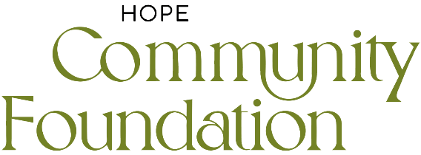

VOLUNTEER PROFILE: PATHWAYS TEAM MEMBER

VOLUNTEER ROLE DETAILS:
Volunteer Role | Pathways Team | Project Day | Monday - Friday
Co-Ordinator | Pat Wharton | Time | 10am – 2pm
VOLUNTEER ROLE SUMMARY:
People are at the heart of all the projects at Hope Community Foundation and the role of the Pathfinder is fundamental to helping individuals and families get the support and services that they need. Working within the Foundation Café at The Hope Centre alongside other Pathfinders and wider Foundation volunteers, our Pathfinders will be connecting people with services within and beyond Hope Community Foundation and strengthening partnership working. Your role will be vital in helping to build rapport, relationship and meaningful connections with people by seeking to identify their wider needs and by signposting them to the most appropriate service to meet those needs.

SPECIFIC ROLE REQUIREMENTS:
- Aged 18 years or over
- Befriending and chatting to clients and visitors within Foundation Cafe
- Working collaboratively and supportively with other volunteers within Hope Community Foundation
- Recognising and identifying the needs of individuals and responding appropriately
- Signposting visitors and clients to relevant support services
- Reporting health and safety and safeguarding concerns to the Safeguarding board
- Adhering to relevant policies, procedures and risk assessments
- Observing confidentiality and data privacy

SKILLS / ABILITIES:
- Good listening skills and communicates effectively
- Ability to introduce yourself and talk to new people confidently, courteously and sensitively
- Ability to learn about the project and the services supported by or supporting the project
- Basic computer literacy skills to be able to record conversations and signpost people

COMPETIENCIES / BEHAVIOURS:
- Empathetic and approachable
- Friendly and hospitable
- Enthusiastic and motivated
- Clean appearance and good personal hygiene
- Punctual and reliable
- Flexible and works well with others
- Heart to see people flourish
- Ensure that your language and behaviour, and the working environment you create is non-threatening and non-discriminatory so as to preserve dignity and respect for all, regardless of race, religion, sex, sexuality, marital status, age, employment status, political persuasion, mental or physical health, or criminal convictions.

